i-access Kiosk
Getting Started

July 2022

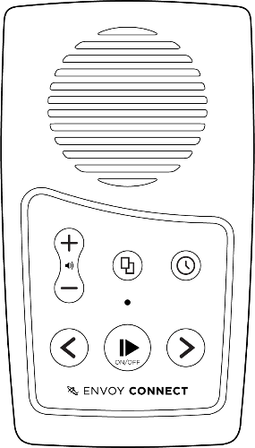

i-access Kiosk – Getting Started

What’s New?
i-access Kiosk software (Kiosk) allows you to download titles from your Vision Australia online Library to your Envoy Connect player or computer.
New features include:
1. Direct access to your ‘MyVA’ account website.
2. Direct access to the Download Folder on your computer desktop.
3. Automatic Player Loading mode.

Important Information
Before choosing the Automatic Player Loading mode, please read the i-access Kiosk User Guide (this mode always removes all titles off your bookshelf as well as your player).
Note that the first time you run Kiosk, the screen that displays the titles on your Envoy Connect player (or computer) may be empty.
If this occurs, select the Next button to display the titles that are on your online bookshelf to download.
The next time you run Kiosk, the titles that have been downloaded to the player or computer will be displayed.

How to Use
Run i-access Kiosk.
With your player turned off, plug it into the computer using the supplied USB data cable.
If you wish to download to your computer, select the Cancel button to return to the main screen where you can change the device type in the File/Options menu.
Kiosk may ask for your library Username and Password.
Once you are logged in, you will be prompted to select the titles on your player (or computer) that you want to remove, and new titles that you want to download.
If you choose to download to the computer, titles will be downloaded into a folder on your desktop called ‘i-access Kiosk Content’.
More information can be found in the i-access Kiosk User Guide.

Contact and Support
i-access Kiosk software will automatically update from time to time.
If you do not have a library account, or for any other assistance, please call the Library on 1300 654 656, or email: library@visionaustralia.org.
End of document

