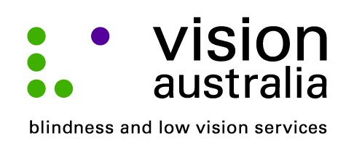
16 September 2014

Facebook Granny stays connected despite blindness
Two years ago, 73 year old Marilyn Pursche from Albury, was devastated when she lost her eyesight overnight.
“It was a shock to wake up with no vision. I was in hospital for about two months while I had tests to find out what happened,” Marilyn explained. “Now, I can see shadows and a little bit of movement.”
Thanks to a recommendation from a friend, Marilyn contacted Vision Australia and joined an eight week Quality Living Group program, which provides peer support to people dealing with vision loss.
“The Quality Living Group helped me to start to come to terms with my vision loss,” said Marilyn. “But, what I really wanted to do was to be able to use my computer again.”
Marilyn now attends a weekly technology training group at Vision Australia’s Albury centre on Olive Street.
“The weekly group is wonderful. Kuini, my trainer, has taught me how to touch type and she has marked the keys on my keyboard with tactile indicators to help me work out the letters,” said Marilyn.
“I use Dolphin Guide Handsfree with Dragon Naturally Speaking software. Dolphin reads aloud the information on my screen while Dragon is a voice recognition software for when I am writing letters.”
Originally from Whyalla in South Australia, keeping in touch with friends and family is very important to Marilyn.
“I’m a Facebook Granny. And, although I can’t see, I use Skype to talk to my sister. She tells me she can see how I am. It makes a big difference to be able to stay connected in this way,”
Vision Australia provides a range of services and supports that assist people like Marilyn to live the lives they choose.
Whether it is help accessing education, developing skills to stay independent at home, or providing social and emotional support and connecting with others, the options are many.
Find out more about Vision Australia’s services today. Call us on 1300 84 74 66, drop in to our local office at 566 Olive St, Albury, or visit our website on www.visionaustralia.org .

